**Math 120  
4.5 Exponential Growth and Decay**

# **Objectives:**

1. Model exponential growth and decay.
2. Use logistic growth models.
3. Choose an appropriate model for data.
4. Express an exponential model in base *e*.

# **Topic #1: Exponential Growth Models**

Recall the formula for continuous interest:



Where is the future value, is the initial value, is the natural base, is the relative growth rate, and is time.

Although it is unlikely that money in an account will grow per continuous interest, many quantities that grow over time are modeled by continuous growth.

Here is the general formula for Exponential Growth:



Where is the future value, is the initial value, is the natural base, is the relative **growth** rate, and is time. Notice it is the SAME formula, just with some differences in the notation.

*Example #1* – Evaluate an Exponential Growth Model

The population of Canada is modeled with the exponential growth model

Where is the population in millions and is the number of years after .



Let *t* be:



Let *A(t)* be:



a) What is the relative growth rate of the population per year?



b) What was the population in ?

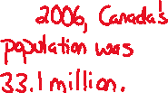

c) Based on the model, what is the projected population in 2029? Round to the nearest tenth.

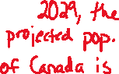

d) When is the population expected to reach 70 million?

This gives _______________plug in and solve the equation:



We can solve by isolating the base and introducing the natural log or by graphing.

We can solve the general equation for using the same techniques discussed in the last section:

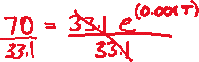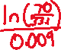

*Example #2* – Build and Evaluate an Exponential Growth Model

The population of Columbia in 2010 was million; the projected population in 2050 is expected to be million. Assume the projection will hold true and that the population will grow based on an exponential model.



a) Find the exponential growth model that describes the population years after .



Let *t* be:



Let *A(t)* be:



We need to solve for . Feel free to graph or isolate the base and introduce logarithms. We can solve the general equation for using the same techniques discussed in the last section. Round to the nearest ten thousandth:

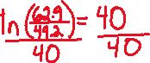

This gives the exponential growth model:

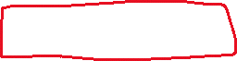

b) Based on the model what is the projected population in ? Round to the nearest tenth.



c) When is the population expected to reach million?



Feel free to set up the equation OR use the “shortcut”

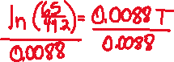

d) When is the population expected to double the size of the population in 2010?



Double the initial value is _______________________ feel free to plug into the model and solve. However, when we divide a number twice as big as the initial value, it is always the number . This gives the formula for doubling time:

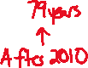

# ***Topic #2: Exponential Decay Models***

Some quantities grow exponentially/continuously over time; others decay.

Here is the general formula for Exponential Decay:



Where is the future value, is the initial value, is the natural base, is the relative **decay** rate, and is time.

Notice it is the ALMOST the SAME formula for growth, but the rate is _____________________



*Example #1* – Build and Evaluate an Exponential Decay Model

The population of Japan in 2010 was million; the projected population in 2050 is expected to be million.



a) Find the exponential decay model that describes the population years after .



Let *t* be:



Let *A(t)* be:

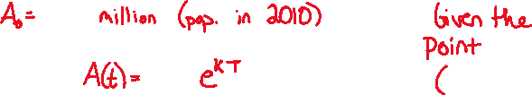

We need to solve for . Feel free to graph or isolate the base and introduce logarithms. We can solve this general equation for using the same techniques discussed in the last section. Round to the nearest thousandth:

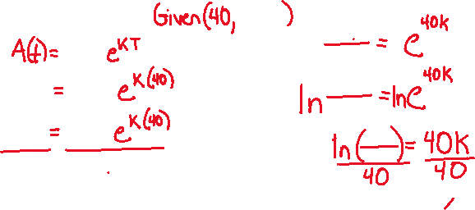

This gives the exponential growth model:



b) Based on the model what is the projected population in ? Round to the nearest tenth.

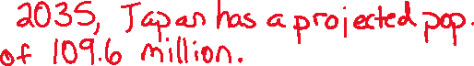

c) When is the population expected to be half the size of the population in 2010?



Half the initial value is __________________________



feel free to plug into the model and solve. However, when we divide a number half as big as the initial value, it is always the number . This gives the formula for half-time:

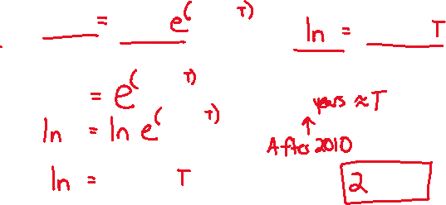

*Exponential Decay and Carbon-14 Dating*

The amount of Carbon-14 in an artifact or a fossil decays exponentially over time. The age of an artifact or a fossil can be determined using the formula:

Where is the amount of Carbon-14 present (in grams), is the original amount of Carbon-14 (in grams), is the natural base, the rate of decay is about grams per year, and is time in years.

Let *t* be:



Let *A(t)* be:



*Example #2* – Exponential Decay Model and Carbon Dating

a) An artifact originally has grams of Carbon-14. How many grams will be present in 800 years? Round to the nearest tenth. Use the model for Carbon-14, where and



b) An artifact originally has 80 grams of Carbon-14. When will the artifact have 20 grams of Carbon-14?

Use the model for Carbon-14, where and



Solve for with any desired technique:

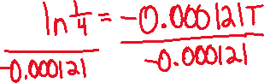

c) A fossil is found during an excavation project. It is determined that the fossil contains of its original Carbon-14. How old is the fossil?

We are asked to solve for time, but we do not have a specific original and new amount of Carbon-14. All we know is the new amount is of the original. Feel free to pick some original value, for example if



then Plug these values into the model and solve for .

However; if the new quantity is of the original quantity, when we divide the new quantity by the original it is always OR , regardless of the original amount.

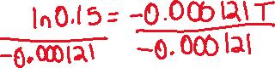

# **Topic #3: Logistical Growth Models**



Exponential growth models have limitations when time increases. The models increase without bound, but nothing in nature grows exponentially indefinitely.

Growth is limited, to model such behavior consider the

Logistical Growth Model:

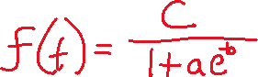

Where is the new quantity, are positive constants, is the natural base, and is time.

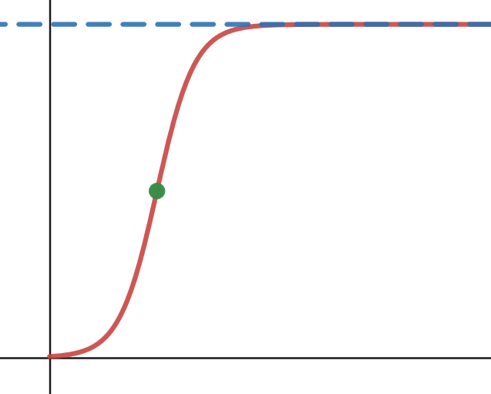

The graph creates an “S” curve. The quantity grows quickly to start, but slows down and flattens out to a horizontal asymptote. The equation of the asymptote is and is the limiting capacity of growth.



Suppose that a disease is spreading though a population and the number of people infected is modeled by the logistical model:

where are the number of people infected weeks after the initial outbreak.

Let *t* be:



Let *f(t)* be:



According to the model, the initial number of people infected at the onset of the epidemic is:

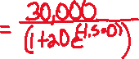

The disease does not spread without bound, eventually the number of people infected flattens out to OR people infected.



Here is a graph of the model:

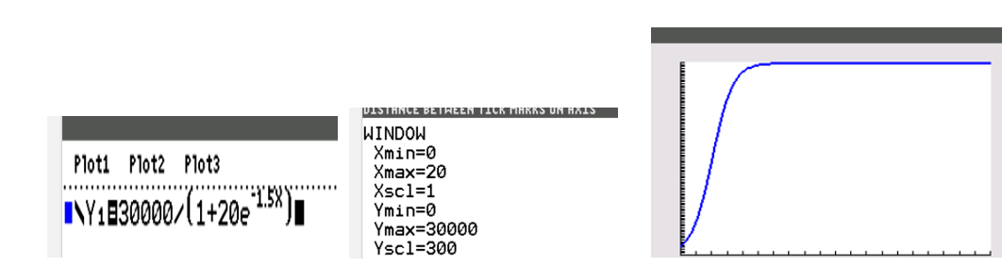

*Example #1* – Evaluate a Logistical Growth Model

The world population over time is modeled by the logistical function

where is the world population in billions and is the number of years after .

Let *t* be:



Let *f(t)* be:



a) According to the model, what was the world population in ? Round to the nearest tenth.

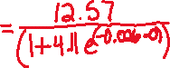

b) According to the model, what was the world population in ? Round to the nearest tenth.

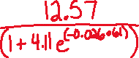

c) Based on actual census data, the population in was billion. How well does the model work with the estimation above?



d) When will the population reach billion?

This gives _________________ and the equation:

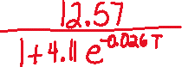

We can cross-multiply, isolate the base, and introduce a natural log.

Here is the graphical solution:

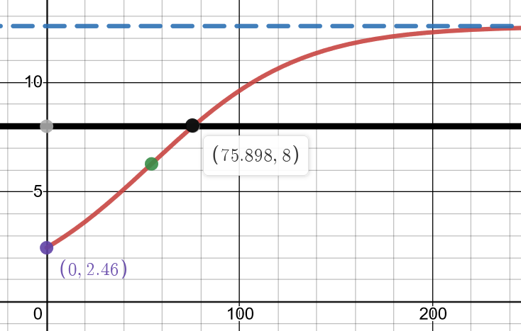

Based on the graph, the population will reach billion in about years after which is in the year 2025.

e) According to the model, what is the limiting size of the world population?

